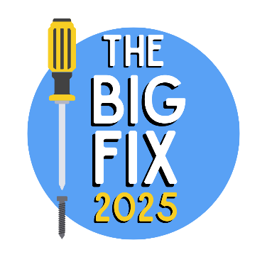

**The BIG FIX 2025 Repair Café Registration**

Thank you for registering to join us in this year’s The BIG FIX on Any Day in May! Your answers from this survey will be used to improve our communication with you and for initial reporting on the event. The survey will take approximately 4 minutes to complete, and all answers will be treated in the strictest confidence.

|  |  |  |  |  |
| --- | --- | --- | --- | --- |
| Name of Repair Café |  | | | |
| Date of The BIG FIX event |  | | | |
| Which part of the British Isles are you? (Please indicate) | England  Northern Ireland  Scotland  Wales | | Channel Islands  Isle of Man  Republic of Ireland | |
| Which county are you in? |  | | | |
| Repair Café email address |  | | | |
| Preferred email address for contact |  | | | |
| Lead contact name |  | | | |
| Have you taken part in The BIG FIX before? (Please indicate) | Yes No | | | |
| How have you heard about The BIG FIX?  Please indicate all and include other/s if applicable) | Recycle Devon social media | Recycle Devon website | | Email invitation |
| Word-of-mouth | Publication/Local newspaper | | Radio |
| Local Authority | Other organisation | | Other: |
| Other: | Other: | | Other: |
| May we contact you about future The BIG FIX events? (please indicate) | Yes No | | | |
| Anything else you would like to add? |  | | | |